# Assignment 6 Machine Learning CS 6375.501

## Dharmam Buch DSB150030

### Level 3 Bonus is done in Java. So, set path of java in command prompt using similar command.

### C:\Users\Dharmam\Desktop\Assignment_6_DSB150030>Path C:\Program Files\Java\jdk1.7.0_79\bin

### Compile using following line, to create a class file. (Included in the folder.)

### C:\Users\Dharmam\Desktop\Assignment_6_DSB150030>javac kmeans.java

### Run using following line.

### C:\Users\Dharmam\Desktop\Assignment_6_DSB150030>java kmeans image3.jpg 3

### Using images 3,4 and 5. From the link

<http://www.utdallas.edu/~axn112530/cs6375/unsupervised/images/>

Results :-



K=3



K=9



K=20



Image

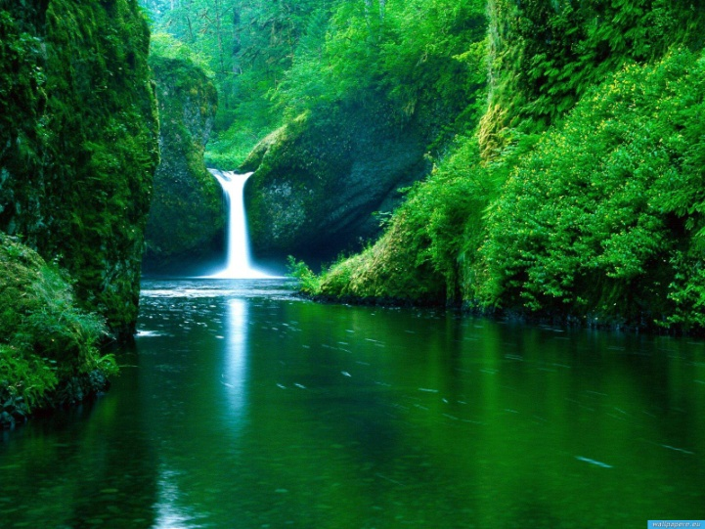

K=3



K=5



K=9



Image

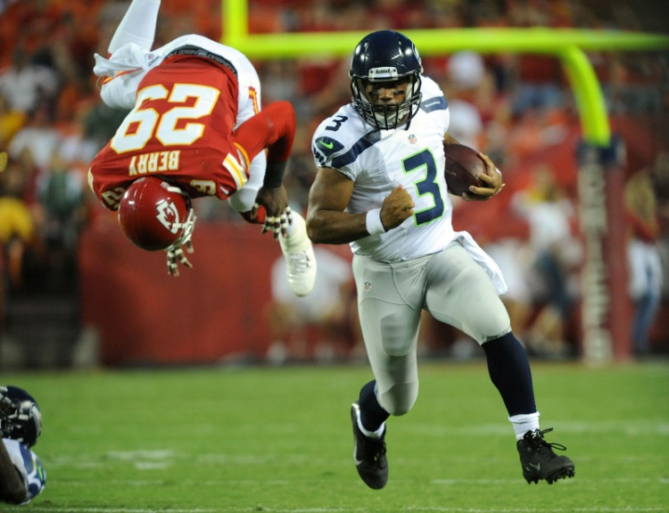

K=5



K=9



K=20

